















<https://youtu.be/SIrDDd2jt7w> Video link

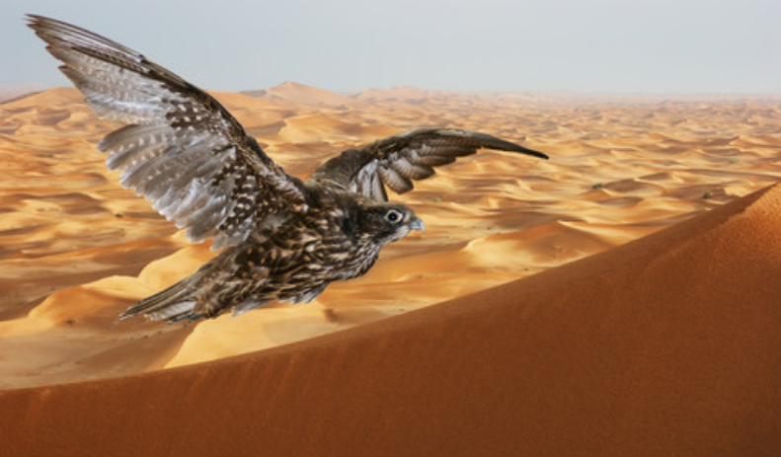

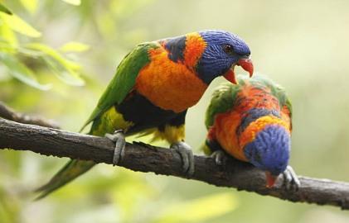

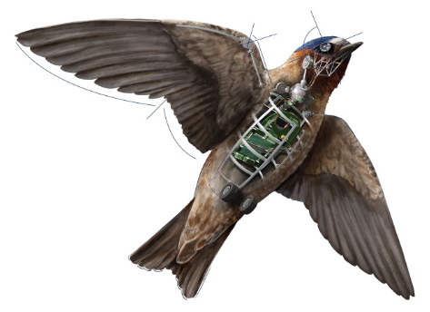

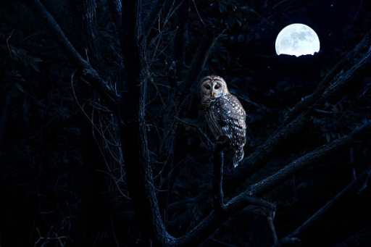

The bright future for drones is inevitable, look up there a majestic bird gliding its wings through the sky encapsulating the beauty of nature, oh look a falcon diving for its pray wow, look at that owl its staring at us… o no… but really they are the latest arsenal in surveillance drones. (for video click here)

Over recent decades the military and government agencies have reportedly been using [drones](https://www.cnet.com/topics/drones/products/)made to look like birds to spy on its citizens.

The bird-like drones not only mimic the flapping wings of a real birds using a pair of crank-rockers driven by an electric motor with sophisticated software capturing high definition intricate details that can be zoomed for clarity to produce fine images that they capture for future or immediate use, in their disguise they can also make chirping sounds, capture their pray or land majestically on branches and realistically turn their body and heads not only for surveillance and tracking through [GPS antenna](https://www.cnet.com/products/magellan-antenna-9300050001/), flight control system and a data link with satellite communication capability for live feeds and further not only are they used for surveillance purposes but have the destructive capabilities of given target e.tc, through the disguise of realism of nature to the naked eye.

Not only in the air has mankind endeavoured to capture realism of nature in mechanised form but also on land and in depths of the sea under the harshest conditions mankind is replicating nature’s creatures in all its forms and disguises, sometimes for the benefit of humanity and in other cases for its destruction.

